Report

This ray tracer includes the following:

* 3 spheres
* Checkerboard plane
* Shadows
* Reflections
* Anti-aliasing
* Arbitrary perspective, location of spheres, and source of light
* Ambient Light

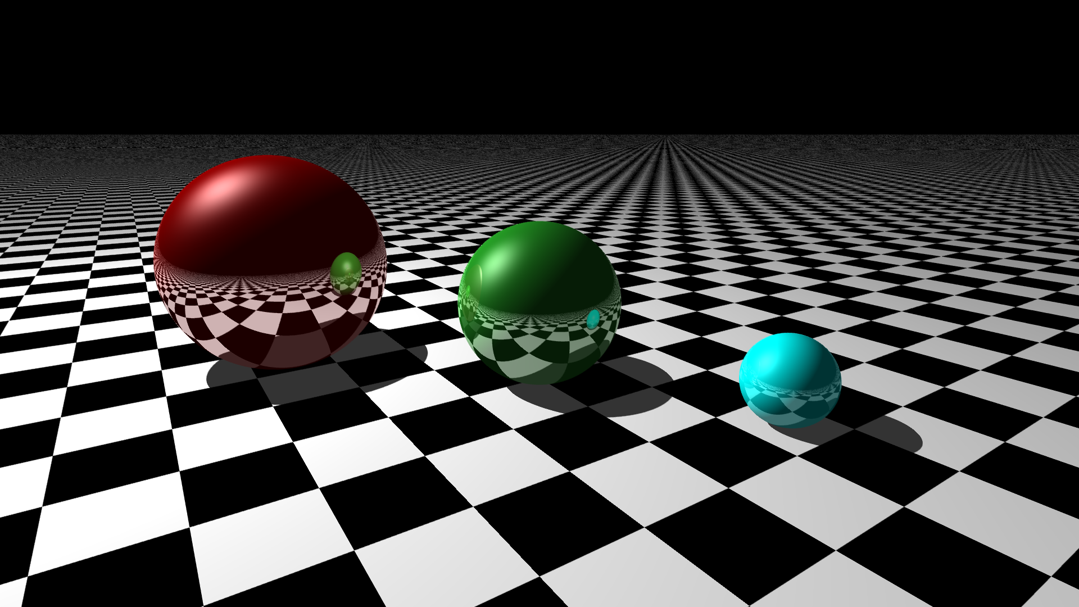

Q. Explain the design of a ray tracer from the perspective of object-oriented programming, as well as the various data structures and algorithms you used.

A. The ray tracer uses multiple classes such as color, camera, light, etc. Each of these classes model the object with the various properties they should hold (eg:- origin and direction for rays), or method functions (which are used throughout the main). Some classes such as sphere use inheritance properties (object is sphere’s parent). The ray tracer uses vectors on numerous occasions for storing values like indices of objects with which the light rays intersect, so that it can be used later to form shadows and reflections. The algorithm I used was to first make the main class then use code to save the image, then all the other classes necessary to make the objects required at the scene. As I progressed with the assignment, I added various methods to implement some of the “cooler” features such as reflections, shadows, and a checkerboard design for the plane.

Q. Explain how a ray tracer implements the transport of light. Talk about how your rays bounce off objects.

A. Each ray is traced from the camera to the objects in the scene. The number of rays are the product of the scene height and width. Every iteration of the ray tracer checks if the light rays intersect with objects in the scene and if they do, shadow, reflection, and mixing of colours are computed accordingly which are then used to compute the colour of the pixel at the point of intersection. The reflection is performed by recursively iterating on the reflected rays. Anti-aliasing sends out multiple light rays which bounce of the surfaces and the average of their colour is filled into empty pixels (this is based on the depth of the object).

Q. Explain how diffusion of light is modeled by a Lambertian (diffuse) material.

A. Light is diffused in all directions on a Lambertian material. So, the intensity of the sphere can be defined by the ambient light falling on it, multiplied by the reflection amount for ambient light (equally dim on every point)

Q. Explain how reflection and refraction of light are modeled by metal and dielectric materials.

A. Light does not refract on metallic surfaces, it only reflects. Since metallic surfaces have high specular values, the light rays hold their geometric properties upon reflection (ie: theC:\Users\Anu\AppData\Local\Microsoft\Windows\INetCache\Content.Word\scene.bmpy reflect at certain angles, not randomly like on matte surfaces). With dielectric materials, most of the light is refracted (speed of light is slower in dielectric materials). The refraction index of every individual material determines how “bent” the light rays will be.